🡪 🡪

Dopamine

L-DOPA

L-tyrosine

Propionate + Hexamethonium (cholinergic antagonist)

Propionate + Propanolol (beta adrenergic antagonist)

Propionate binds to a beta-adrenergic receptor

Propionate binds to a cholinergic receptor

No

Yes

No

Yes

Does it reduce the change in heart rate compared to propionate alone?

Does it reduce the change in heart rate compared to propionate alone?

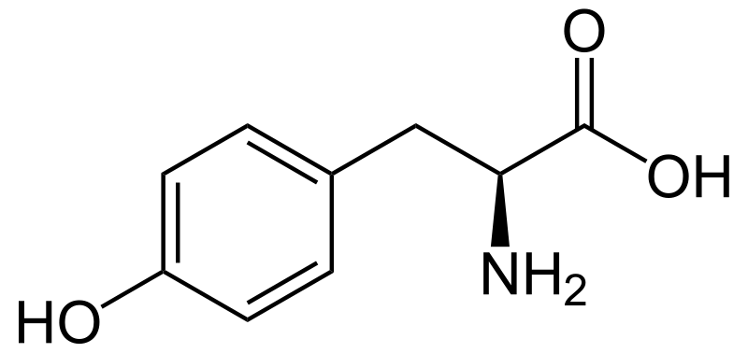

L-tyrosine